November 7, 2024

**J1466 TagSpecification**

Justin,

The addressing of the Modbus registers can be found in GF_express, downloaded from Gefran.

I would like to do an initial trial with the PLCnext on the existing Gefran 3850T, which we worked on earlier this year.

The Modbus addressing is different from the GFX4 which we will be using, but it will be good to do some screen development for the final solution.

For this testing, the goal is for a machine operation screen and a Grafana Time series monitor from InfluxDB.

The machine operation screen would be ‘similar’ to the screen shot from the original Kent machine #5. The screen shot I sent on Teams earlier this week. This open to changes, and is a starting point.

Possibly the operators screen is setup in PLCengineer visualization. I would like to see how this all works together.

Not sure what the best method for Measurement storage may be. Should Python look at the measurement to see if the zone is ON then add this to the measurement list??

Tag

* + - * Machine#

Measurement (per active zone)

* + - * PV Temperature present value
      * SP Temperature setpoint value
      * Power Amperage or percentage?
      * Status (alert if open cartridge element)

This is the original Gefran 3850T

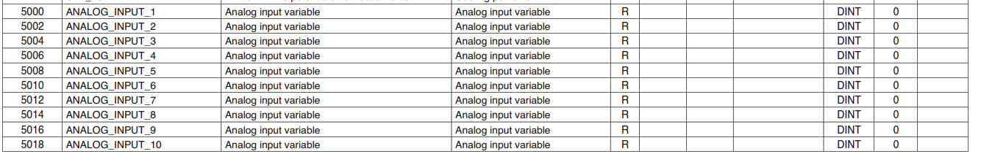

David Kane

President

Kane Engineering Group Inc.